H.T No
Regulations:
A18

Sreenidhi Institute of Science and Technology
(An Autonomous Institution)
Code No: 7K201 Date: 23-Aug-2023 (FN)

B.Tech I-Year II- Semester External Examination, Aug/Sept-2023 (Supplementary)
ENGINEERING MECHANICS FOR CIVIL ENGINEERING (CIVIL)

Time: 3 Hours Max.Marks:70

Note: a) No additional answer sheets will be provided.
b) All sub-parts of a question must be answered at one place only, otherwise it will not be valued.
c) Missing data can be assumed suitably.
Bloom's Cognitive Levels of Learning (BCLL)

Remember | L1 | Apply | L3 | Evaluate | L5
Understand | L2 | Analyze | L4 | Create | L6

Part - A Max.Marks:20

Answer all QUESTIONS.

 |  | BCLL | CO(s) | Marks
1 | What are the steps followed while drawing free body diagrams? | L2 | CO1 | [2M]
2 | What is meant by limiting friction and impending motion? | L2 | CO2 | [2M]
3 | State Perpendicular axis theorem. | L1 | CO3 | [2M]
4 | Define the principle of virtual work | L1 | CO4 | [2M]
5 | Explain the difference between Rectilinear and Curvilinear motion. | L4 | CO5 | [2M]
6 | Write kinetic equation of motion for a disc of mass ‘m’ and radius ‘r’ rotating with an angular acceleration ‘α’ and the applied Torque is ‘M’ | L3 | CO6 | [2M]
7 | What is the Centroid of a Quarter circle of radius 2 m? | L3 | CO1 | [2M]
8 | Differentiate between “Mass moment of inertia” and “Area moment of inertia” | L2 | CO3 | [2M]
9 | Differentiate the kinematics and kinetics. | L2 | CO6 | [2M]
10 | Define the radius of gyration and polar moment of inertia. | L1 | CO4 | [2M]

Part – B Max.Marks:50
ANSWER ANY FIVE QUESTIONS. EACH QUESTION CARRIES 10 MARKS.

 |  |  | BCLL | CO(s) | Marks
11. | a) | Two forces of magnitude 50 N and 30 N are acting at a point. If the angle between the two forces is 120⁰, determine the magnitude and direction of the resultant force. | L5 | CO1 | [5M]
 | b) | Two spheres, each of 1000N and of radius 25cm rest in a horizontal channel of width 90cm as shown in figure. Find the reaction at the point of contact A, B and C.  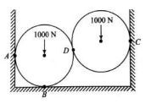 | L5 | CO1 | [5M]
12. | a) | Explain the principle of operation of a screw-jack with a neat sketch. | L2 | CO2 | [5M]
 | b) | Determine the axial forces induced in the members AB, DB and DE of a truss as shown in figure  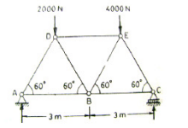 | L5 | CO2 | [5M]
13. | a) | Determine the centroid of the quarter-circle whose radius is R | L3 | CO3 | [5M]
 | b) | Calculate the Moment of Inertia about the centroidal x and y for the section shown (All dimensions are in mm)  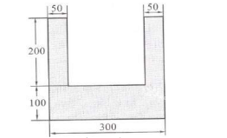 | L5 | CO3 | [5M]
14. | a) | A homogeneous ladder, having a mass M and length ‘l’ is held in equilibrium by a horizontal force P as shown in figure. Using Virtual work methods, express P interms of M.  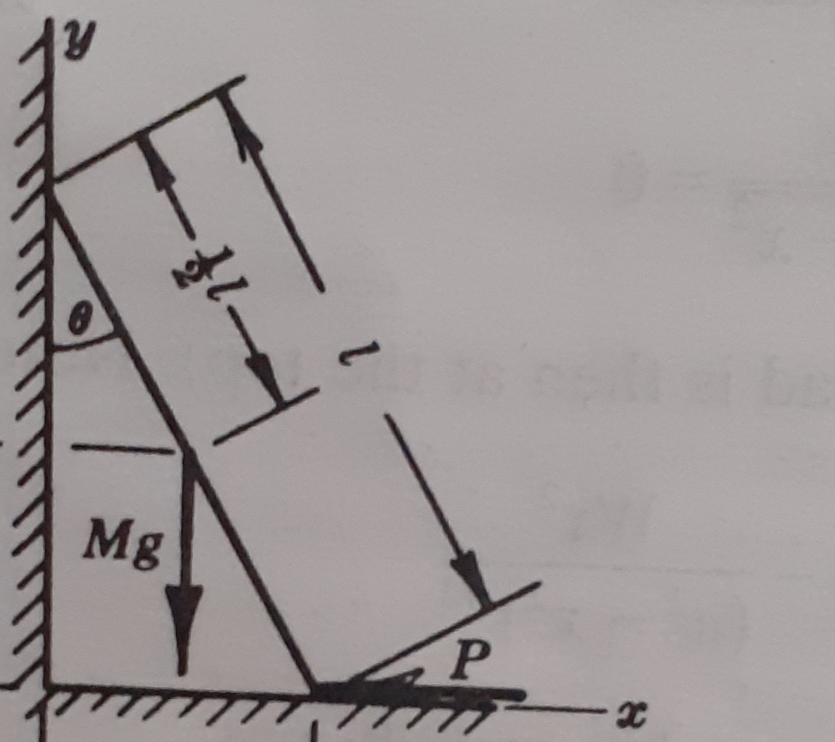 | L4 | CO4 | [5M]
 | b) | Two weights W and w are supported as shown in figure by a bar of negligible weight that is pivoted about an axis at O perpendicular to the plane of the paper. Discuss equilibrium.  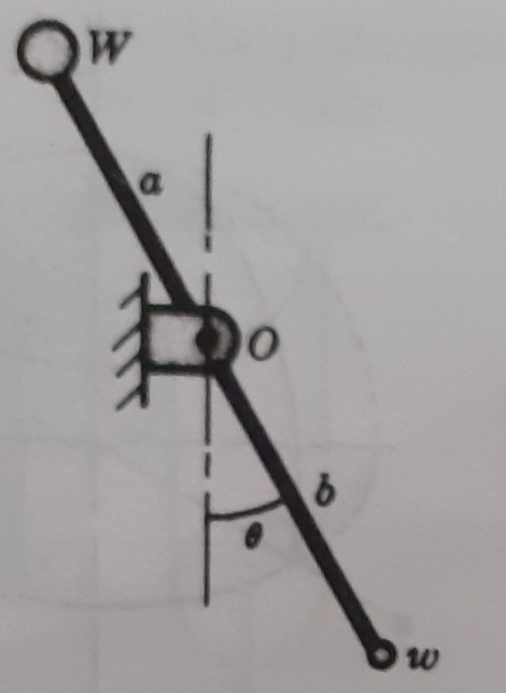 | L4 | CO4 | [5M]
15. | a) | Two blocks A and B are connected with an inextensible but flexible string, as shown in figure. Let the system be released from rest. Determine the velocity of the block A after it has moved a distance of 0.7m. Assume that the coefficient of friction between block A and the plane is 0.31. The masses of the blocks are m_{A}=95kg and m_{B}=143kg.  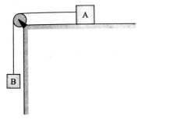 | L5 | CO5 | [5M]
 | b) | An aircraft moving horizontally at a speed of 360 kmph and at a height of 490 m towards a target on the ground, releases a bomb, which hits a target. Find (i) Time required for the bomb to reach the target on the ground;  (ii) the velocity and the direction with which the bomb hits the target. | L5 | CO5 | [5M]
16. | a) | A ladder of length l makes an angle θ with the horizontal floor and leans against a vertical wall. Show that the center of the ladder move on a circular path of radius (1/2) l | L4 | CO6 | [5M]
 | b) | A homogeneous sphere and a homogeneous cylinder roll without slipping , simultaneously from rest at the top of an inclined plane to the bottom. Which reaches the bottom first ? What is the acceleration of each ? | L4 | CO6 | [5M]
17. | a) | The resultant of two concurrent forces is 2500N and the angle between the forces is 90⁰. The resultant makes an angle of 46⁰ with one of the forces. Find the magnitude of each force. | L5 | CO1 | [4M]
 | b) | Find the forces in the member CD of a truss as shown in figure which carries a horizontal load of 12kN at the point D and a vertical load of 18kN at the point C.  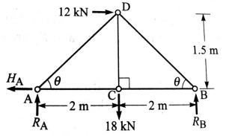 | L5 | CO2 | [3M]
 | c) | Determine the mass moment of inertia of a cylinder shaft of 100mm diameter and 2.5m height with the center of gravity axes parallel to the height. (Density, ρ=8000kg/m³). | L5 | CO3 | [3M]
18. | a) | What are the different types of equilibrium and explain by assuming bead is placed on the wire bent as a circle? | L2 | CO4 | [4M]
 | b) | An elevator weights 2500 N and is moving vertically downwards with constant acceleration. Write the equation for the elevator cable tension. Starting from rest it travels a distance of 35 metres during an interval of 10 seconds. Find the cable tension during this time. Neglect all other resistances to motion. What are the limits of cable? | L5 | CO5 | [3M]
 | c) | A flexible chain of length l and mass m kg/m is released when it has a free overhang of c meters. What will be its speed when leaving the smooth table? | L4 | CO6 | [3M]

-- 00 -- 00 –

